2026 Mercado Libre Seller Guide: Store Setup Process and Sales Growth Strategies
The Latin American e-commerce market is experiencing rapid growth. As the largest e-commerce marketplace in Latin America, Mercado Libre operates across 18 countries and regions with more than 200 million monthly active users, earning the nickname “the Amazon of Latin America.” As competition in the US and European e-commerce markets intensifies, more sellers are entering this blue-ocean market. Lower competition density and higher average order value potential have made Mercado Libre one of the most attractive e-commerce opportunities in 2026.
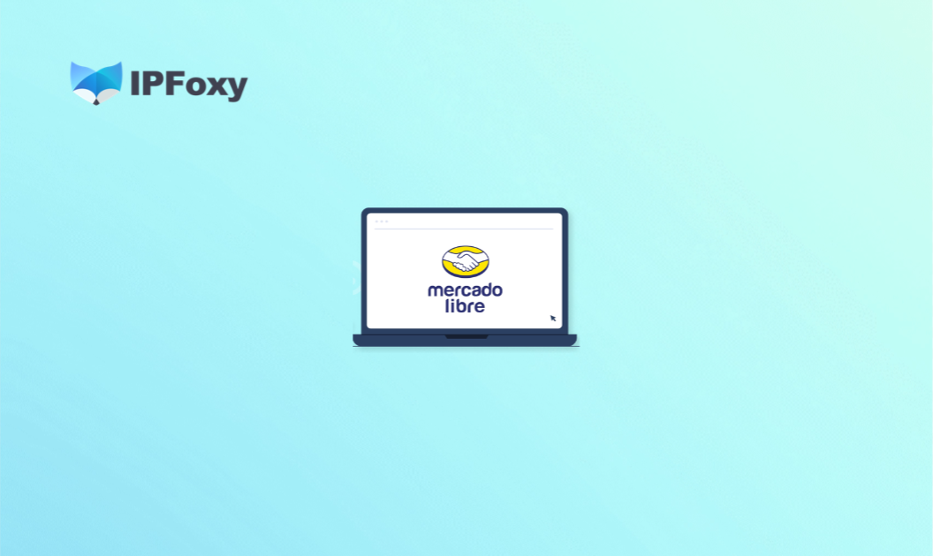


I. Mercado Libre Seller Registration Requirements
Before starting the Mercado Libre seller registration process, understanding the platform’s entry requirements in advance can help avoid repeated document submissions and application rejections.

1.Business Qualification Requirements
Core documents include: company business license, legal representative ID card, mainstream e-commerce store links, and sales screenshots.
Notably, according to the platform policy update released in September 2025, Chinese sellers are no longer required to submit sales proof during registration. As long as business qualification documents are complete, applications can be submitted directly, significantly lowering the entry barrier.

2.Payment Account Preparation
Mercado Libre supports USD settlements. Sellers need to prepare a USD bank account in advance (must be a company receiving account) or register with payment platforms such as Payoneer.
It is recommended to complete payment account registration and verification before submitting the seller application to avoid delays in product listings after approval.

3.Logistics and Warehouse Setup
Logistics capability is an important factor in Mercado Libre’s review process. The platform encourages sellers to operate both self-fulfillment and overseas warehouse (FULL warehouse) models simultaneously.
Compared with self-fulfillment, overseas warehouses offer clear advantages in payment cycles (2 days after delivery confirmation versus 5 days for self-fulfillment), traffic exposure, and promotional event eligibility.
For new sellers, preparing at least a warehouse solution for the Mexico or Brazil main site is recommended.

4.Login Environment and Account Security
Mercado Libre has certain requirements for login IP environments. Sellers are advised to maintain a fixed and stable network environment and avoid frequent IP switching, which is a common trigger for account linking and suspensions.
It is also recommended to use an independent business email address that is completely separated from personal accounts.
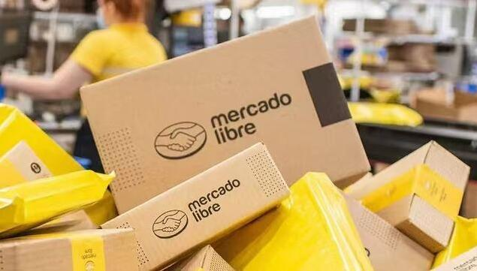

II. Mercado Libre Seller Registration Process
Once all documents are prepared, sellers can complete the Mercado Libre registration process through the following steps. The overall process is straightforward, but each step requires careful attention to detail.

1.Submit the Seller Application
Complete the official application form, including basic information, business overview, and store operation plans, ensuring all details match the business license.

2.Reply to the Initial Review Email
Only respond to emails ending with “@mercadolibre.com.” Sellers must reply within 5 business days. If additional documents are requested, they must be submitted within 3 business days; otherwise, the application may be closed.

3.Register the Account
After passing the initial review, use the registration link sent by the account manager to fill in the company name, store name, Unified Social Credit Code, email address, and password.
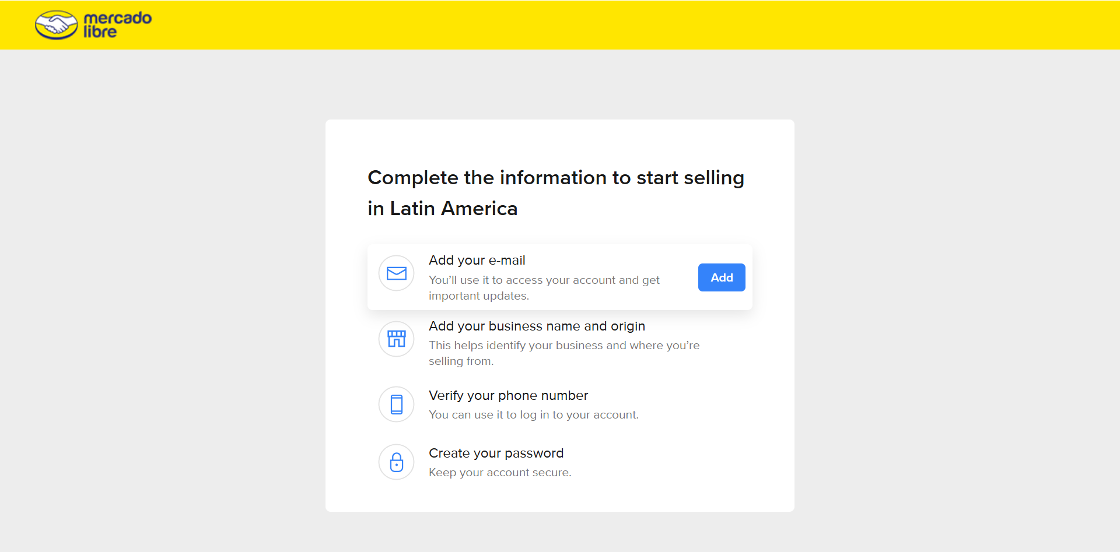

4.Complete Business Verification
Upload the business license in PDF format and provide the company address, postal code, and contact information.

5.Bind Payment Tools and Configure Logistics
Once completed, the full registration process is finished, and sellers can officially begin operating on Mercado Libre.
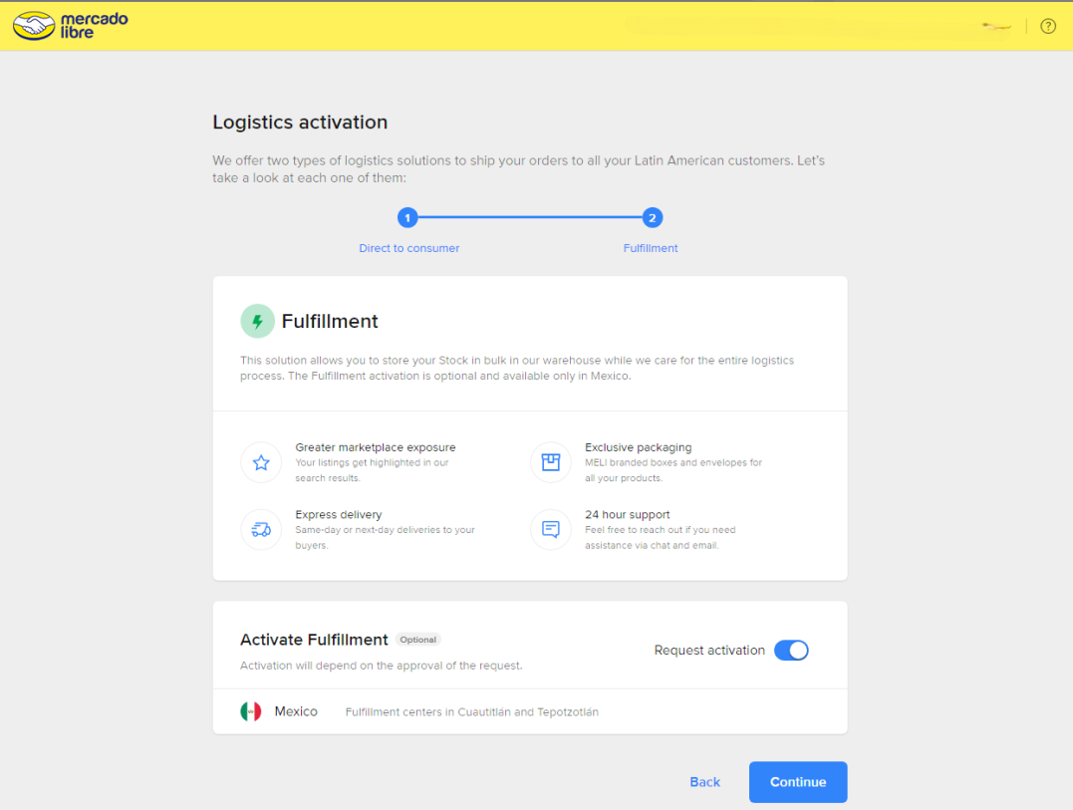

III. Core Mercado Libre Operation Challenges and Solutions
Successfully completing Mercado Libre registration is only the first step. During the early operation stage, sellers often encounter several critical issues that can directly impact sales performance.

1.Store Review Failure
The most common reasons are inconsistent information across submitted documents (such as mismatched store names and company names) or incorrect file formats.
Solution:
Carefully verify consistency between application forms and official documents. Submit clear PDF files when providing supplementary materials. If applications are repeatedly rejected, contact the account manager for clarification.

2.Multi-Account Association
Mercado Libre currently allows multiple accounts under the same entity, but sellers must strictly comply with anti-association policies:
● Independent information: each account must use a separate email address and tax ID.
● Anti-association measures: avoid logging into multiple accounts using the same IP address. Using a professional Anti-detect browser for multi-account management is recommended.
● Sub-account authorization: teams can create sub-accounts with limited permissions for customer service or product listing management. Sub-accounts cannot modify payment information, ensuring financial security.
Solution:
Payment accounts and business licenses should maintain a strict one-to-one relationship. Sellers must avoid fake orders, false reviews, and infringing products.
To create isolated account environments, sellers can use real dedicated static residential proxy resources from professional proxy providers such as IPFoxy Proxies and integrate them into an Anti-detect browser to simulate real-user environments and fully separate account fingerprints.
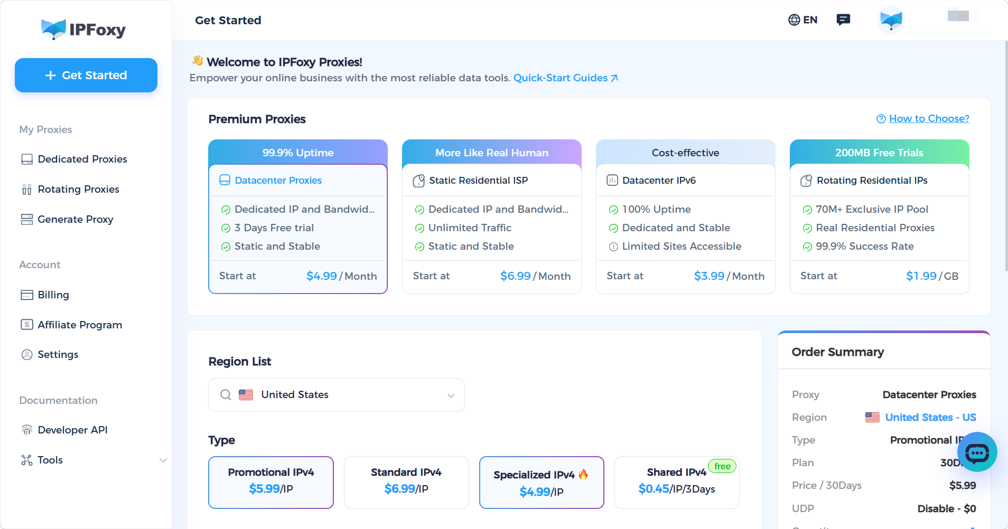

3.ccount Suspension
When Mercado Libre suspends a store, the platform usually sends an email explaining the reason. Common causes include selling infringing products, violating platform sales policies (such as false advertising or review manipulation), account security risks (such as suspicious account associations), and poor performance metrics (such as high late shipment rates or excessive customer complaints).
Solution:
If sellers believe the suspension was a mistake, they can file an appeal through the platform’s appeal system and provide supporting evidence. Sellers should also thoroughly review their business practices and make necessary corrections to avoid violating platform rules again.

IV. Fast Sales Strategies for New Mercado Libre Stores
After resolving operational issues, new stores need to focus on product selection, SEO, advertising, and product page optimization simultaneously to achieve fast sales growth.

1.How to Find Low-Competition Products
The first principle for new sellers is avoiding oversaturated categories and focusing on niche markets.
Use Mercado Libre sales rankings and keyword tools to identify products with medium search volume, fewer competitors, and leading sellers with fewer than 1,000 reviews.
According to the platform’s 2026 policies, key recruitment categories include electronic accessories, automotive parts, fashion products, and home goods.
Recommended product pricing:
● Self-fulfillment model: above USD 15
● FULL warehouse model: above USD 23
This helps cover logistics costs while maintaining healthy profit margins.

2.Mercado Libre SEO Optimization
Limited exposure is common for new stores. Sellers are advised to prioritize overseas warehouses, as FULL warehouse listings receive higher search traffic weight.
At the same time, improving listing quality is critical. Within the platform algorithm, the combined weight of “advertising relevance,” “traffic history,” and “listing relevance” accounts for approximately 60%.
Key Mercado Libre SEO optimization points include:
● Place core keywords at the beginning of titles and use natural local-language expressions instead of keyword stuffing.
● Fill in as many attribute fields as possible, since more complete information improves ranking weight.
● Use clean white-background main images with at least six images total, while secondary images should demonstrate product usage scenarios.
● Include long-tail keywords naturally within product descriptions and address common buyer concerns while emphasizing unique selling points.

3.Advertising Strategies
New sellers are advised to launch product ads immediately after listing products. During the early stage, the primary goal should be exposure accumulation rather than strict ACOS targets.
Specific strategies include:
● Start with automatic campaigns to gather conversion data, then switch to manual campaigns after identifying high-converting keywords.
● Closely monitor the Share of Voice metric, which reflects advertising competitiveness for target keywords.
● Increase budgets two weeks before major promotions and combine them with platform promotional campaigns.
If advertising ROI is unstable during the early stage, sellers can adopt a single-product-per-ad-group strategy, placing only one SKU in each campaign for easier exposure analysis and more flexible ACOS and budget adjustments.

4.Localized Product Detail Pages
Consumer shopping habits and aesthetics in Latin America differ significantly from those in China. Since purchasing decisions often take longer, persuasive product pages directly impact conversion rates.
Localized product pages should include:
● Product descriptions written in local languages with lifestyle-oriented images aligned with local aesthetics.
● Certification labels such as CE and FCC to strengthen buyer trust.
● Fast customer service response times, since negative review rates directly impact account weight.
Simply translating domestic product pages without localization should be avoided, as cultural differences can significantly reduce conversion rates.

V. FAQ
Q: Why are Mercado Libre accounts easily suspended?
The main reasons include account association (multiple accounts sharing devices, IPs, or payment tools), policy violations (fake orders, false reviews, selling prohibited or infringing products), and abnormal login activity triggering platform security systems.
Q: Is Mercado Libre suitable for individual sellers?
The platform has no restrictions on seller size. Individual entrepreneurs with valid business qualifications can participate, and small-to-medium sellers also have opportunities to generate sales.
Q: What is the difference between a local store and a global seller account on Mercado Libre?
A local store is registered and operated within the target country, providing stronger traffic support, faster payment cycles, and more complete after-sales systems.
A global seller account is operated directly by Chinese companies and allows management of multiple sites from a single backend, with lower entry barriers. Many sellers begin with global seller accounts and later establish local entities after validating their business model.

VI. Conclusion
In 2026, Mercado Libre remains a high-potential e-commerce opportunity for Chinese sellers. The platform continues lowering entry barriers, optimizing logistics costs, and increasing policy support, while the Latin American market still offers significant growth opportunities.
The earlier sellers enter the market, the faster they can accumulate reviews, ranking weight, and operational data advantages. Hopefully, this guide can help sellers avoid common pitfalls and grow more efficiently on Mercado Libre.

